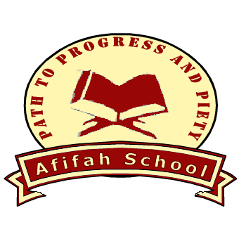

An Independent Islamic School

for pupils aged 2-16

Afifah Academy manages Afifah School,

which consists of a Nursery, a Primary School and a Secondary Girls School.

Registered Charity No: 1120284 Company No. 5512936

Principal: Abdul Huy Malek LLB (Hons)

Assalamu Alaykum Respected Parents/-Guardians,
Re: Distance Learning
In light of the Government's announcement regarding Coronavirus on Wednesday, we have decided to temporarily close the school from Friday 20th March 2020, until further notice. Our students will continue to be educated via Distance Learning.
We wish to thank all parents for their ongoing commitment, resilience and determination throughout
these unprecedented times. Our heartfelt appreciation to you and your families for helping to keep
the school open as long as possible.
We have put procedures in place to develop distance / home learning resources for all year
groups. These resources are designed to encourage your children to complete a few hours of home learning a day during this temporary closure period. Further details will be published on our website.
GCSE and SATS examinations will not be taking place in May and June 2020. We will communicate further details to the affected students as soon as they are announced.
We urge parents to ensure they are up to date with payment of fees and continue to make monthly payments. If there is a reduction in our fee income (on which we survive), this will affect our financial viability to operate during this temporary period. We need to ensure that our committed staff are paid their wages promptly at the end of each month. We trust we have your full cooperation in respect of this matter.
Parents who are Key Workers must email details of their employment, so that we can assess whether we are in a position to make alternative arrangements.
Please use our email address ( admin@afifahschool.co.uk ) to make general enquiries. Kindly remain patient when sending emails to the school, as we will have skeletal staff during the school closure and will try to respond to emails as quickly as possible. It is important to remember that staff will be juggling school work with home commitments and so there may be some delay before you receive a reply.
As the virus increases across the world and within the UK, we want you to know that the safety and
wellbeing of our children, parents and staff is our number one priority. We care about each and every
one of you and so we urge you to take every precaution you can to protect yourselves and your
families: follow Public Health England advice and call NHS111 if you feel unwell. Our prayers are with you and your families and we ask Allah for His forgiveness, mercy and protection from any harm.
Was salaam

Abdul Huy Malek LLB (Hons)
Principal

from any harm.
Was salaam
Abdul Huy Malek LLB(Hons)
Principal

86 Clifton Street, Old Trafford, Manchester, M16 9GN.

Tel : 0161 872 1516 Email : admin@afifahschool.co.uk Website : www.afifahschool.co.uk
Friday 20th March 2020/25th Rajab 1441 AH

