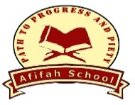

Home Learning Information for Parents

LEARNING PACKS   | Primary and High School teachers have prepared Learning Packs for students to complete over the next 2 weeks until Friday 3rd April 2020.
PUPIL ASSET – PARENT APP:  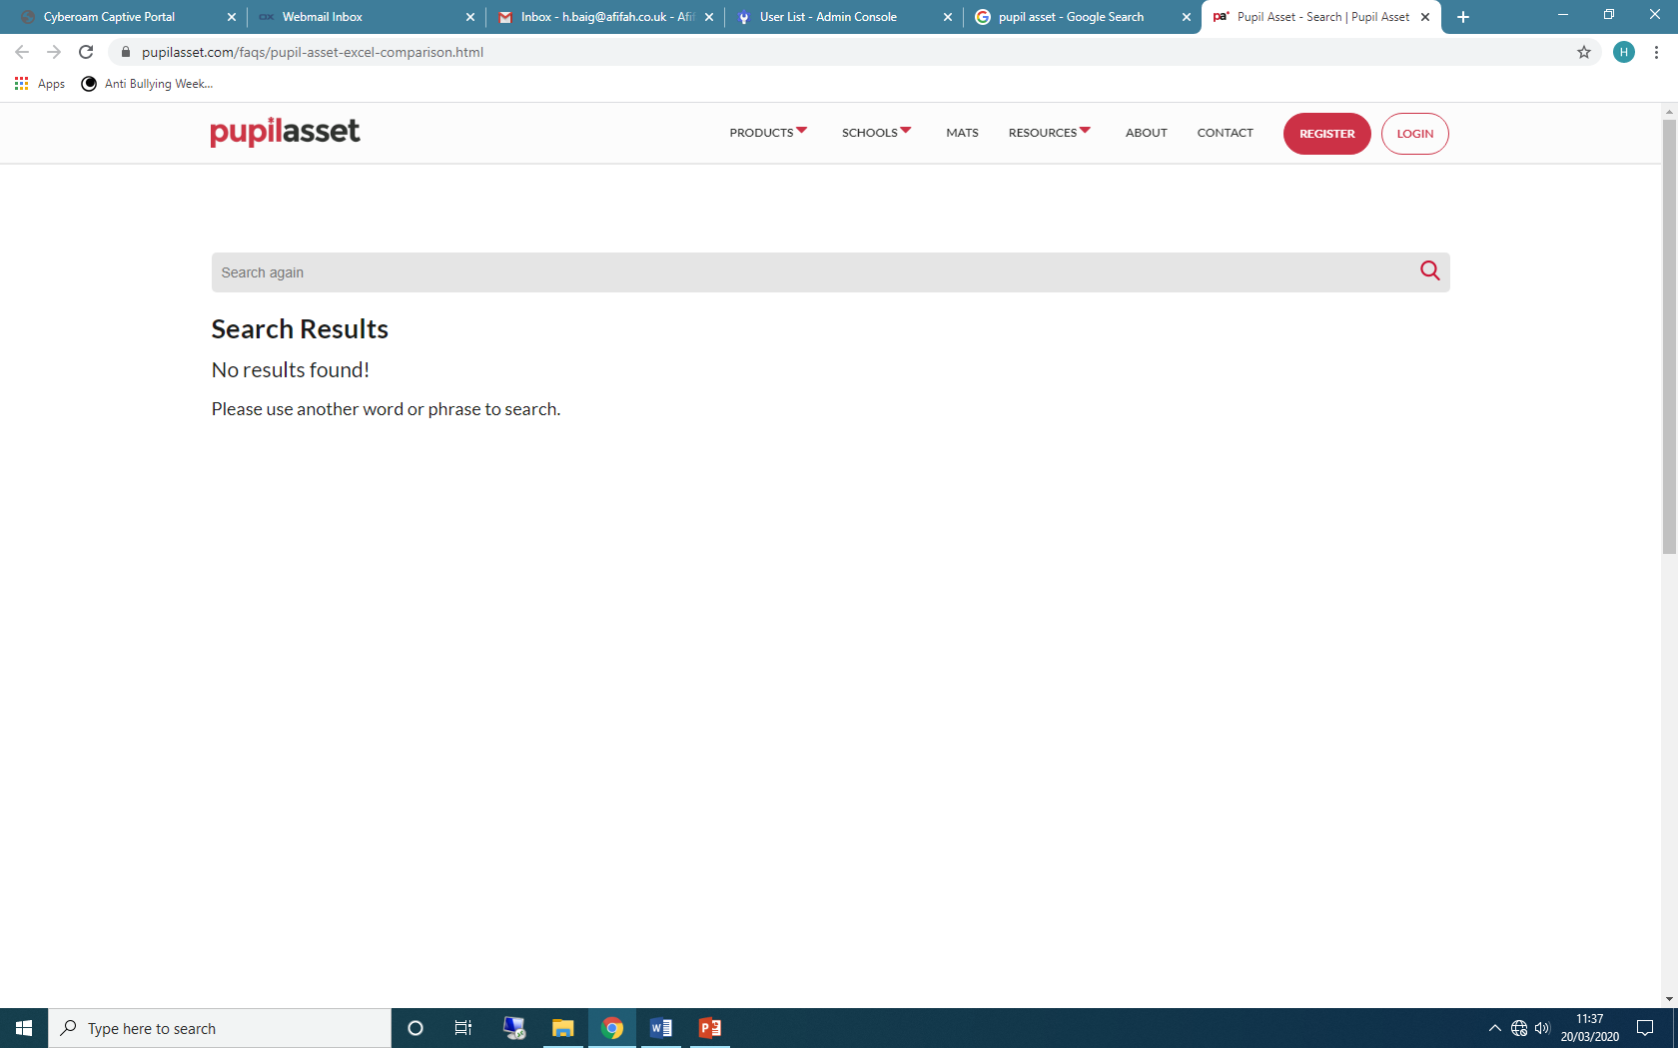 | This will be used for any communication between schools and parents. Please ensure you have installed the mobile parent app and are using it on a daily basis.  Details of how to download the app and how to log in can be found on the following link:  https://www.pupilasset.com/help/how-to-guide/parental-communication-contactsemailsmspattr-/parents-app-overview-a-guide-for-parents  Your username is the email address that school has on record for you.
GOOGLE CLASSROOM:  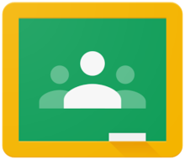 | This will be used for sharing resources, marking and assigning student work and for feedback. This will be starting from 20th April 2020.  The log ins will be provided to all the students (via text) closer to the time.
ZOOM AND GOOGLE MEET:  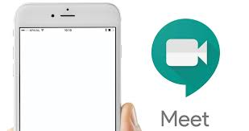  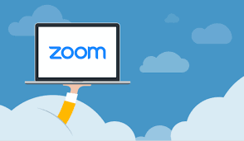 | This will be used to share videos and online teaching potentially for Year 5,6,9 and 10. This may be starting from 20th April 2020.

